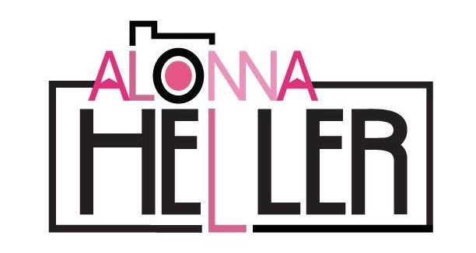

alonnaheller.com | 608.297.8831| alheller09@marianuniversity.edu

Education
Bachelor of Arts, Marian University, Fond du Lac, WI May 2020
Major: Graphic Design,
Double Major: Marketing & Public Relations
Minor: Studio Art
Cumulative GPA: 3.9/4.0

Study abroad program, Florence University of Art, Florence, Italy August – December 2019

Skills
- Proficient in Adobe Photoshop, Illustrator, Premier Pro, Lightroom, InDesign
- Expertise in social media marketing strategies on platforms including, Instagram, Facebook and Constant Contact

Work and Related Experience
Destination Lake Winnebago Region, Fond du Lac, WI December 2018 - February 2019
Intern
- Organized amateur snow sculpting competition as public event
- Designed poster to be distributed for recruitment purposes
- Recruited and developed criteria for judgement of contest
- Engaged with community as a face of Sturgeon Spectacular event

Career Services Office, Marian University, Fond du Lac, WI February – May 2018
Intern
- Created recruitment video for externship program using Adobe Premier Pro
- Designed logo for event t-shirts
- Developed trifold presentation boards for campus events in Adobe Illustrator
- Conceptualized design and layout of trifold brochures
- Scheduled and conducted student photo and video shoots for marketing materials

Alonnaheller.com
Freelance Graphic Designer/Photographer January 2015 – Present
- Design logos for various industries
- Schedule and conduct professional photo shoots for local businesses
- Create professional headshots and family portraits
- Produce bi-monthly newsletter for Fond du Lac Morning Rotary Club
- Commissioned to create installation artwork for several Fond du Lac businesses

Alonna Heller, Page 2

Gallery Frame Shop, Fond du Lac, WI March 2017 – Present
Social Media Coordinator, Designer
- Produce digital and print signage and create ads: radio and print for regional advertisement
- Generate social media content for Facebook, Instagram, Google, Pinterest, and Blogs
- Edit and size photos for print purposes
- Design and manage website on WIX; web design platform
- Email marketing through Constant Contact; customer relationship management system

Lake Arrowhead Campground, Montello, WI May 2014 – Present
Graphic Designer
- Produce marketing materials, designed gift certificates, and created videos to increase campground reservations and awareness of services
- Create social media posts to boost client engagement on Facebook, Instagram, and Snapchat
- Direct photo shoot and edited materials for marketing

Night Shift Leader May 2017 – Present
- Open drawers and deposit currency to safe location after end of shift
- Field all customer issues and handle in professional manner
- Maintain positive work environment among team members

Campus Involvement
Marian University Art Club, Member, 2016 – Present
- President, 2018 - Present
- Secretary, 2017
Sabre Voice News Paper, Reporter/Graphic Artist, 2018 – Present
- Designed layout for print edition in Adobe InDesign
Marian University Honors Program, Member, 2016 – Present
Marian University Business Club, Member, 2017

